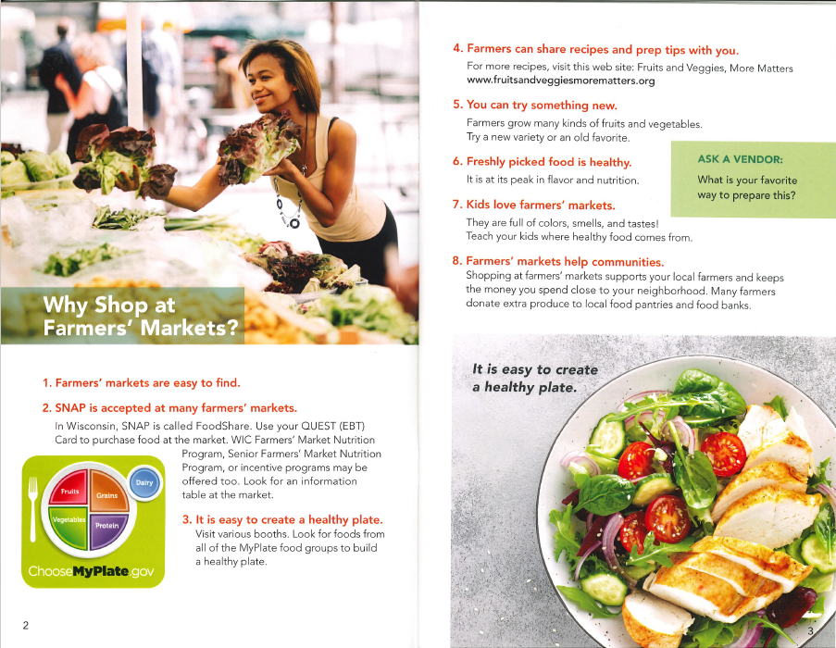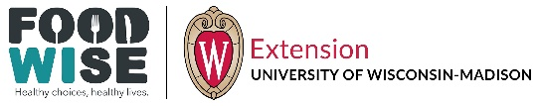

FoodWIse education is funded by the USDA Supplemental Nutrition Assistance Program - SNAP and Expanded Food and Nutrition Education Program - EFNEP. An EEO/AA employer, University of Wisconsin-Madison Division of Extension provides equal opportunities in employment and programming, including Title VI, Title IX, the Americans with Disabilities Act (ADA) and Section 504 of the Rehabilitation Act requirements.